Case Study on the Demonstration of Network Communication Models (OSI / TCP-IP) Using a Network Simulation Tool

Aim
To show how the OSI and TCP/IP models work in real communication by tracing one web request across a small network built in Cisco Packet Tracer.

Objective
- Study the seven layers of the OSI model and the four layers of the TCP/IP model.
- Build a small network with a switch and a router in a simulation tool.
- Trace an HTTP request from a client to a web server and record what each layer does.
- Compare the two models and map their layers to each other.

Problem Statement
How does a web request (HTTP) travel across a small network that has a router and a switch, and which layer of the OSI and TCP/IP models handles each step?

Selected Network Scenario
A Client PC Browsing a Web Server Across a Router

Overview
A PC opens a web page that lives on a server in another network. One router joins the two networks, and each network has its own switch. The simulation records these steps:
- Name lookup with DNS
- Address lookup with ARP
- Connection setup with the TCP three-way handshake
- Page request and page reply with HTTP
- Connection close with TCP

Network Requirements

Client Network (LAN A)
- PC0 and PC1 with addresses in 192.168.1.0/24
- Switch0 joining the PCs to the router

Router
- Router0 with one interface in each network
- Router0 acts as the default gateway for both networks

Server Network (LAN B)
- Server0 at 10.0.0.10 running the HTTP and DNS services
- Switch1 joining the server to the router

Simulation Tool
- Cisco Packet Tracer in Simulation mode
- Event list filtered to ARP, DNS, TCP, HTTP and ICMP

Network Models Analysis
Model | Layers | Advantages | Limitations
OSI | 7 | Each layer has one clear job, so each step is easy to name and each fault is easy to place | Few real protocols follow it exactly
TCP/IP | 4 | Built around the protocols the Internet runs on | Several jobs share one layer, so there is less detail

Why Trace a Web Request?

Reasons
- One page load touches almost every layer.
- The path crosses a switch and a router, which work at different layers.
- Simulation mode shows every packet one step at a time.
- A fault is easy to create, and it shows which layer breaks.

Communication Process
PC0 sends an ARP request to find the router's MAC address

↓

PC0 sends a DNS query for www.college.local (UDP, port 53)

↓

PC0 and Server0 open a TCP connection (SYN, SYN-ACK, ACK) on port 80

↓

PC0 sends the HTTP GET request

↓

Server0 sends the HTTP reply with the web page

↓

PC0 and Server0 close the TCP connection

Simulation Phases

1. Network Planning
Devices Used
- Two PCs, one server, two switches and one router
- Two networks: 192.168.1.0/24 and 10.0.0.0/24
- One web address: www.college.local

Deliverables
- IP addressing table

Device | Interface | IP Address | Subnet Mask | Default Gateway
PC0 | NIC | 192.168.1.10 | 255.255.255.0 | 192.168.1.1
PC1 | NIC | 192.168.1.11 | 255.255.255.0 | 192.168.1.1
Router0 | Gig0/0 | 192.168.1.1 | 255.255.255.0 | Not needed
Router0 | Gig0/1 | 10.0.0.1 | 255.255.255.0 | Not needed
Server0 | NIC | 10.0.0.10 | 255.255.255.0 | 10.0.0.1

2. Network Design
Design Includes
- Topology with the router between the two switches
- Copper straight-through cables on every link
- Cisco 2960 switches and a Cisco 2911 router

Deliverables
- Topology diagram

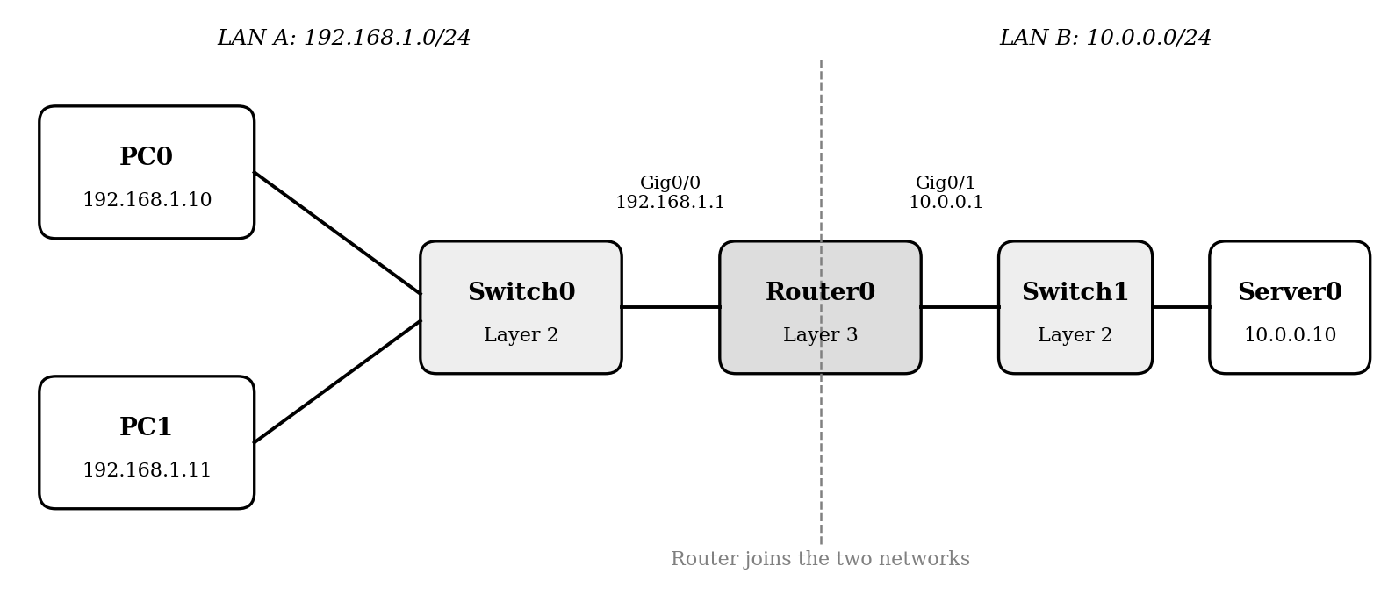
Figure 1: Network design used in the case study

3. Configuration
Router0
enable
configure terminal
interface gigabitEthernet0/0
ip address 192.168.1.1 255.255.255.0
no shutdown
exit
interface gigabitEthernet0/1
ip address 10.0.0.1 255.255.255.0
no shutdown
end

End Devices
- PCs: set the IP address, subnet mask, default gateway 192.168.1.1 and DNS server 10.0.0.10
- Server0: set the IP address 10.0.0.10, subnet mask and default gateway 10.0.0.1
- Server0 services: turn HTTP on, turn DNS on, and add an A record that maps www.college.local to 10.0.0.10
- Switches need no configuration

Deliverables
- Working network with all link lights green

4. Testing
Testing Types
- Connectivity test with ping
- Name resolution test
- Web access test
- Failure test

Test Cases
Test Case | Expected Result
Ping from PC0 to 192.168.1.1 | Reply received
Ping from PC0 to 10.0.0.10 | Reply received through the router
Open http://www.college.local in PC0 browser | Web page loads
Open http://10.0.0.10 in PC0 browser | Web page loads, with no DNS step in the event list
Clear the default gateway on PC0, then ping 10.0.0.10 | Ping fails
Turn the HTTP service off on Server0, then open the site | Web page does not load

5. Packet Analysis
Steps
- Switch Packet Tracer to Simulation mode and set the event list filter.
- Open the Web Browser on PC0 and enter http://www.college.local.
- Press Capture / Forward and watch each packet move.
- Click a packet and read the OSI Model tab and the PDU details.
- Repeat at PC0, Switch0, Router0, Switch1 and Server0.

Layer Mapping
OSI Layer | TCP/IP Layer | Data Unit | Used in This Case Study | Device Level
7 Application | Application | Data | HTTP, DNS | PC0, Server0
6 Presentation | Application | Data | Format of the web page data | PC0, Server0
5 Session | Application | Data | Browser to server conversation | PC0, Server0
4 Transport | Transport | Segment | TCP port 80, UDP port 53 | PC0, Server0
3 Network | Internet | Packet | IPv4 addresses, ICMP | Router0 and end devices
2 Data Link | Network Access | Frame | Ethernet, MAC addresses, ARP | Switches, Router0, end devices
1 Physical | Network Access | Bits | Copper cable signals | All devices

What Each Device Reads
Device | Layers Used | Work Done
PC0 | 1 to 7 | Builds the HTTP request, then adds a TCP header, an IP header and an Ethernet header.
Switch0 | 1 and 2 | Reads the destination MAC, learns the source MAC and forwards the frame. It floods the ARP broadcast.
Router0 | 1 to 3 | Removes the Ethernet header, reads the destination IP, picks the exit interface, lowers the TTL by 1 and adds a new Ethernet header.
Switch1 | 1 and 2 | Does the same job as Switch0 on the server network.
Server0 | 1 to 7 | Removes the headers layer by layer, passes the request to the web service and sends the page back the same way.

Screenshots
[add: Packet Tracer screenshot of the event list after loading the page]
[add: Packet Tracer screenshot of the OSI Model tab for one packet at PC0]
[add: Packet Tracer screenshot of the same packet at Router0]

Comparison of OSI and TCP/IP Models
Criteria | OSI | TCP/IP
Number of layers | 7 | 4
Developed by | ISO | US Department of Defense
Approach | Reference model, written before the protocols | Built around working protocols
Top layers | Application, Presentation and Session are separate | One Application layer covers all three
Bottom layers | Physical and Data Link are separate | One Network Access layer covers both
Use in practice | Teaching and fault finding | The Internet runs on it
Seen in Packet Tracer | Seven layers listed in the OSI Model tab | Protocols such as HTTP, TCP, IP and Ethernet in the PDU details

Results
- The page load ran in this order: ARP, DNS, TCP handshake, HTTP request, HTTP reply, TCP close.
- Switch0 and Switch1 read only Layer 2. They never look at IP addresses.
- Router0 reads up to Layer 3. It removes the old Ethernet header, picks the exit port from the destination IP and adds a new Ethernet header.
- IP addresses stay the same from PC0 to Server0. MAC addresses change at the router, and the TTL drops by 1.
- Each layer adds its header on the way down (encapsulation) and removes it on the way up (de-encapsulation).
- Packet Tracer lists seven layers in the PDU details. TCP/IP groups the same work into four layers, so both models describe one process.

Conclusion
Tracing one web request shows that the OSI and TCP/IP models describe the same process. OSI gives seven labels that make each step easy to name. TCP/IP matches the protocols that actually ran: HTTP, DNS, TCP, IP and Ethernet. A switch works at Layer 2. A router works at Layer 3, and the end devices use every layer. When a layer fails, the request stops there, so thinking in layers is a quick way to find a fault. Packet Tracer made each of these steps visible in a few clicks.

